📘 ADVANCED E-COMMERCE FRONTEND
React-Based Frontend Project

Submitted by:
[Your Name]
Role: Frontend Developer
Technologies: React, Redux/Context API, Tailwind CSS/Bootstrap, Axios

🟦 1. Project Overview
The Advanced E-commerce Frontend is a modern web application built with React that simulates a full-featured e-commerce platform. Users can browse products, filter and sort catalogs, manage a shopping cart, simulate user authentication, and enjoy a responsive, visually appealing interface.
This project demonstrates advanced frontend development practices, including component-based architecture, state management, API integration, and performance optimization.

🟦 2. Project Description
The application allows users to:
- Browse a product catalog with categories, filtering, and sorting
- Search for products using an autocomplete search bar
- Add, remove, and update items in the shopping cart
- Simulate user authentication (login/logout)
- Persist cart and user data using LocalStorage
- View responsive layouts across mobile, tablet, and desktop
- Experience smooth performance with optimized React patterns

🟦 3. Project Objectives
- Build a component-based e-commerce frontend using React
- Implement state management for shopping cart and user data
- Enable responsive product grid with filtering, sorting, and search
- Use modern CSS frameworks (Tailwind CSS or Bootstrap) for styling
- Integrate Axios for product API calls
- Apply LocalStorage for persistence
- Demonstrate advanced frontend practices like lazy loading and performance optimization

🟦 4. Features
- Product catalog with filtering (category, price, ratings) and sorting (price, popularity)
- Interactive shopping cart (add, remove, update quantities)
- User authentication simulation (login/logout)
- Product search with autocomplete
- Persistent shopping cart and user session via LocalStorage
- Responsive design for all devices
- Optimized performance (lazy loading, memoization)

🟦 5. Technologies Used
- React 18 – Component-based architecture
- Redux Toolkit or Context API – State management for cart and user data
- React Router – Navigation between pages
- Tailwind CSS / Bootstrap – Responsive styling
- Axios – Fetch product data from APIs
- LocalStorage – Persist cart and user data
- ES6+ JavaScript – Modern JS patterns and modules

🟦 6. Setup and Installation Instructions
- Clone the repository:
- git clone <repository-url>
- cd week5-ecommerce-frontend
- Install dependencies:
- npm install
- Start the development server:
- npm start
- Open the application in a browser at http://localhost:3000

🟦 7. GitHub Project Structure
week5-ecommerce-frontend/
│── src/
│ ├── components/ # Reusable UI components (ProductCard, Navbar, Cart, SearchBar)
│ ├── pages/ # Page components (Home, ProductDetails, Cart, Login)
│ ├── redux/ # Redux Toolkit slices and store (or Context API providers)
│ ├── utils/ # Utility functions (API calls, helpers)
│ ├── App.js # Main application component with routing
│ ├── index.js # Entry point
│ └── styles/ # CSS or Tailwind configuration
├── public/ # Public assets
├── package.json # Dependencies and scripts
└── README.md # Project documentation

🟦 8. Component Hierarchy
App
├── Navbar
│ └── SearchBar
├── HomePage
│ ├── ProductGrid
│ │ └── ProductCard (xN)
│ ├── Filters
│ └── SortOptions
├── ProductDetails
├── CartPage
│ └── CartItem (xN)
├── LoginPage
└── Footer
Explanation:
- Navbar – Top navigation with search bar and cart icon
- ProductGrid – Displays all products with filters and sorting
- ProductCard – Individual product display with add-to-cart button
- CartPage – Manages shopping cart items and checkout simulation
- LoginPage – Simulates user login/logout functionality

🟦 9. How to Use
- Open the application in the browser.
- Browse products on the Home Page.
- Use filters and sorting to refine product selection.
- Click Add to Cart on products to add them to your shopping cart.
- Access the Cart Page to update quantities or remove items.
- Use the Search Bar to find products quickly.
- Simulate login/logout using the Login Page.
- Cart and user session persist using LocalStorage.

🟦 10. Key Technical Requirements Met
Requirement | Implementation
React for component-based architecture | All UI implemented with reusable React components
State management for cart/user | Redux Toolkit or Context API managing global state
Responsive product grid with filtering & sorting | Tailwind CSS / Bootstrap + dynamic filters
Shopping cart functionality | Add, remove, update items; persist in LocalStorage
User authentication simulation | Login/logout page and session persistence
Product search with autocomplete | SearchBar component with live suggestions
Performance optimization | Lazy loading images, memoization, minimized re-renders

🟦 11. Screenshots of Working Application
- Home Page & Product Grid:
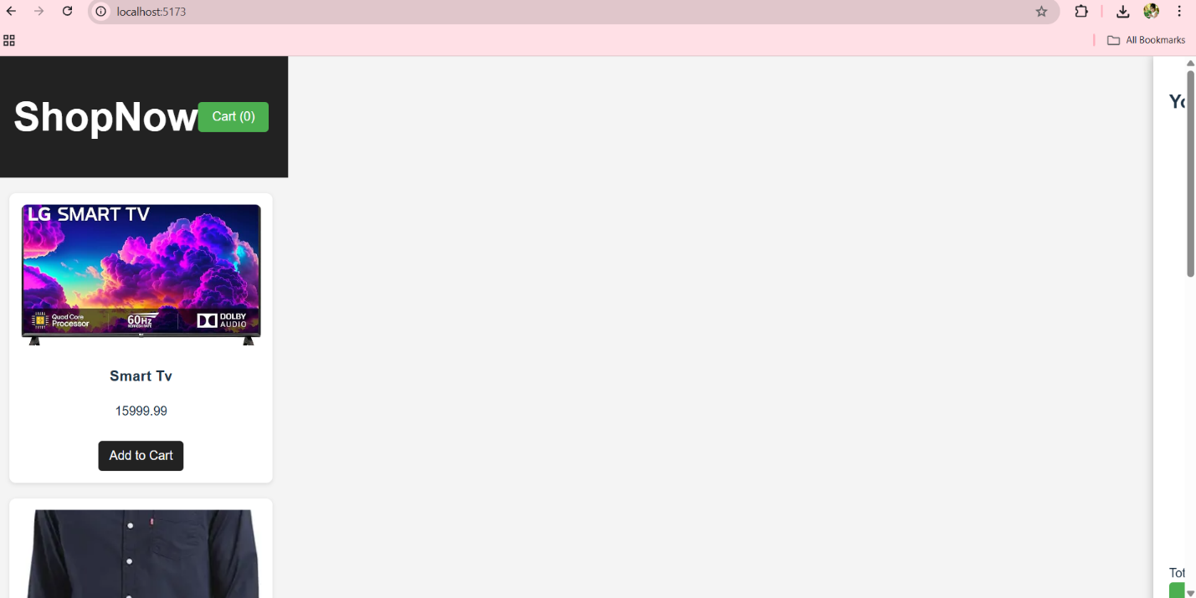
- Product Details Page:
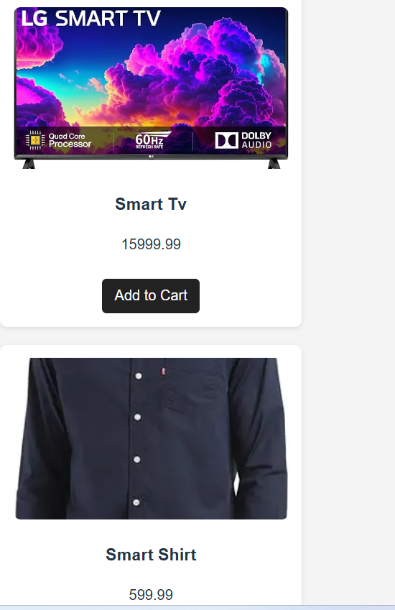
- Shopping Cart Page:
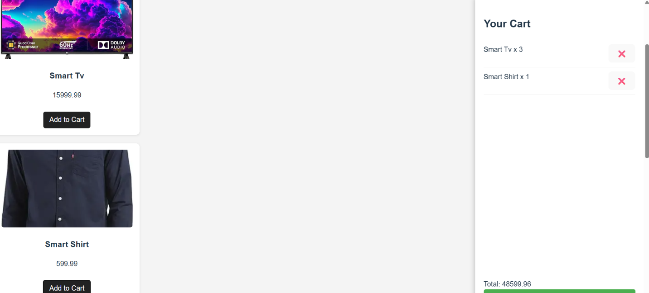

🟦 12. Conclusion
This project demonstrates an advanced React-based e-commerce frontend with complete shopping cart functionality, product search, filtering, sorting, user authentication simulation, and responsive design. It showcases modern frontend techniques, state management, and performance optimization, fulfilling all project objectives and technical requirements.

